**Project 1: 2 Link Manipulator Arm: Overview**

**Project Description:**

Demonstrates a kinematic model of a robot manipulator. Specifically, this project shows a 2D 2-Link robot arm that works via inverse kinematics within MATLAB.

**Project Features:**

* Input Coordinates
* Animation of Robot
* Choosing Best Solution
* Object Collision Detection
* Displays Final Coordinates and Theta Values

***Figure 1: Example Output***

**Files Included:**

**How to Use:**

Open



Click Run



3 Interfaces:

***Move Robot Input:*** Shows Current Coordinates and Input New Coordinates.

***2D Robot GUI:*** Graphical User Interface Of 2D 2-Link Arm.

***Command Window:*** Displays Current Theta Values and Position.

**Modifiable Code:**

**ObstacleOn = 0**: No Obstacle

**ObstacleOn = 1 or 2**:

Two Different Placements of the Rectangle

**Arm1 & Arm2 Lengths**: Customizable

**Frames:** Give Control over Smoothness the Animation

**Debug = 1:** Displays Hemisphere of Reachable Area

**Project 1: 2 Link Manipulator Arm: Math**

**Math**

**

**Matlab Function : InverseKinematicsFunction.m**

**Project 1: 2 Link Manipulator Arm: Problems/Solutions**

**Find Best Solution Based on Distance:**

**Best Solution based On Distance Diagram**

**Best Solution based On Distance MATLAB Code**

**Find Best Solution (Coordinates Not Within Reach):**

**Best Solution (Coordinates Not In Reach) Diagram**

**Best Solution (Coordinates Not In Reach) MATLAB Code**

**Project 1: 2 Link Manipulator Arm: Examples**

**Input Coordinates Example:**

***Figure 2: Input Coordinate: Original Position***

***Figure 3: Input Coordinate: New Coordinate Position***

**Best Solution Example (Coordinates Within Reach):**

***Figure 4: Best Solution: Original Position***

***Figure 5: Best Solution: New Position***

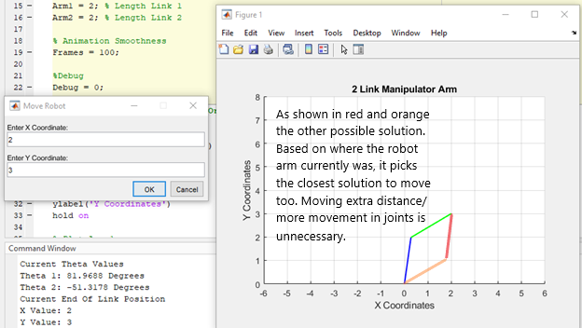

**Best Solution Example (Coordinates Not in Reach):**

***Figure 5: Best Solution2: Original Position***

***Figure 6: Best Solution2: New Position***

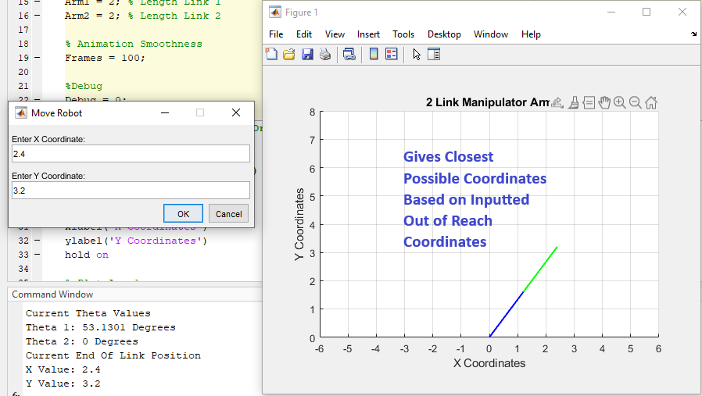

**Obstacle Collision Detection Example (Arm 1) :**

***Figure 7: Collison Arm 1: Original Position***

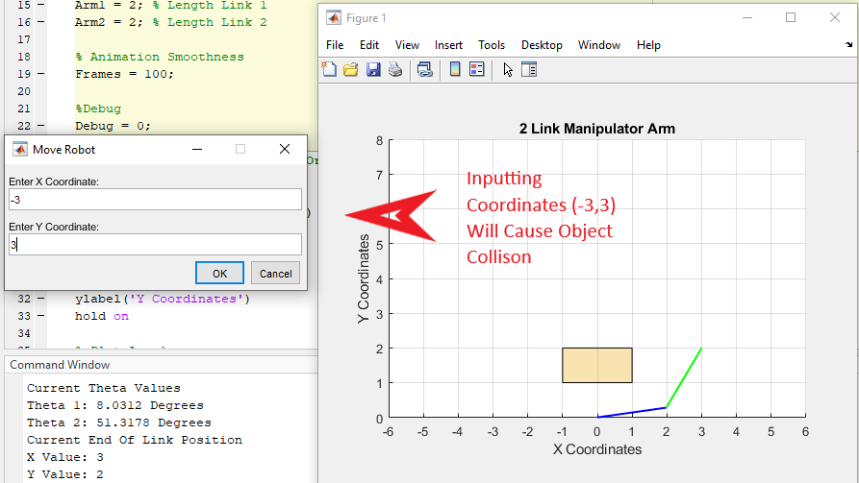

***Figure 8: Collison Arm 1: New Position***

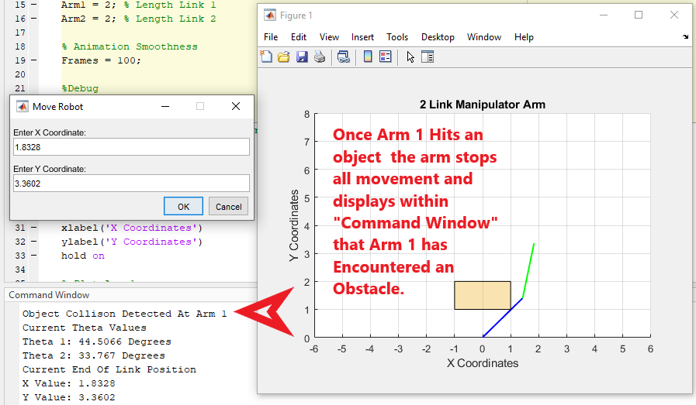

**Obstacle Collision Detection Example (Arm 2):**

***Figure 9: Collison Arm 3: Original Position***

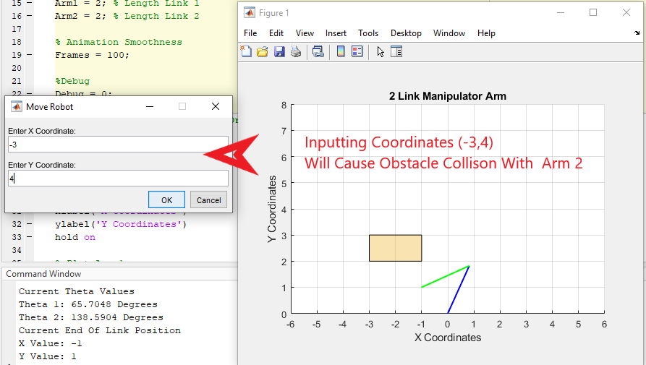

***Figure 10: Collison Arm 2: New Position*** 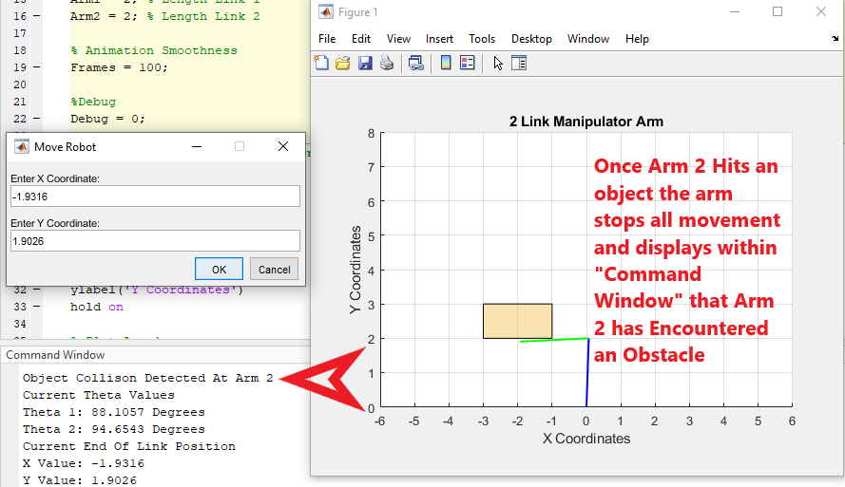

**If Inputted Coordinate Is Not in Quadrants I or II Example:**

***Figure 11: Not with Reachable Quads: Original Position***

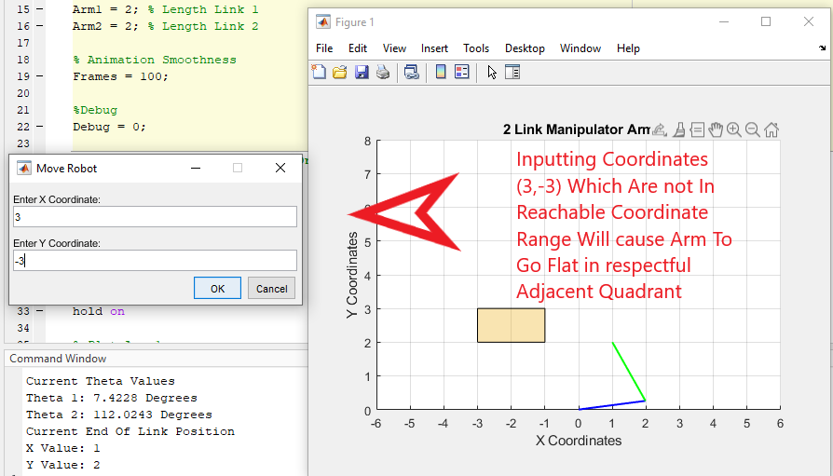

***Figure 12: Not with Reachable Quads: New Position***

